Introduction to Programming with AI – Exam Preparation
Exam preparation for the “Introduction to Programming with AI” course at SoftUni. At the exam you have 4 hours to submit solutions for 5 problems.
Submit all your solutions to the SoftUni Judge: https://alpha.judge.softuni.org/contests/exam-preparation/5291.

Energy Calculator
An electricity company uses three tariffs:
- Day tariff: 0.10 EUR per kWh (active between 6:00 and 22:00)
- Night tariff: 0.07 EUR per kWh (active between 22:00 and 6:00)
- Peak tariff: 0.12 EUR per kWh (active between 18:00 and 21:00)
Write a JS function to calculate the price for given consumption.

Input and Output
You are given:
- Hour of consumption (integer in 24-hour format, e.g. 0–23)
- Energy consumed in kWh (real number)
Calculate and print the tariff and price (with 2 decimal places) in the format shown below:
Input | Output
electricityPrice(7, 1.8); | Day tariff: 0.18 EUR
electricityPrice(20, 2.43); | Peak tariff: 0.29 EUR
electricityPrice(22, 4.5); | Night tariff: 0.32 EUR

Power Plant Blueprint
A photovoltaic power plant has the form of rhombus, where "@" represents a solar panel, "|" and "-" represent the main wiring (cables) and the "+" represents the inverter point, where the plant is connected to the power grid.
Write a JS function to print a rhombus of size n x n like at the examples below:
Input | drawRhombus(5); |  | drawRhombus(7); |  | drawRhombus(9);
Output | @  @|@  @-+-@  @|@  @ |  | @  @|@  @@|@@  @--+--@  @@|@@  @|@  @ |  | @  @|@  @@|@@  @@@|@@@  @---+---@  @@@|@@@  @@|@@  @|@  @

Input and Output
- The rhombus size will be an odd integer n (3 ≤ n ≤ 101).
- Print exactly n lines, each holding exactly n chars (use leading and trailing spaces where needed).

Energy Slots
An electricity company uses three tariffs:
- Day tariff: 0.10 EUR per kWh (active between 6:00 and 22:00)
- Night tariff: 0.07 EUR per kWh (active between 22:00 and 6:00)
- Peak tariff: 0.12 EUR per kWh (active between 18:00 and 21:00)
You are given a set of energy consumption slots, represented as objects in this format:
- {start:"10:15", end:"12:40", kW: 1.5}
Write a JS function to calculate the total price for the slots. For each slot the price is calculated as:
- number of minutes * tariff / 60

Input and Output
- The input comes as variable number of parameters, each holding an object {start, end, kW} in the format from the example. Use 24-hour time format.
- Return as output the total energy price, rounded to 4 decimal places.
Sample input and output:
Input | console.log(calcEnergyPrice(  {start:"10:15", end:"12:40", kW: 1.5},  {start:"20:30", end:"07:40", kW: 0.9},  {start:"17:30", end:"18:45", kW: 2.2}  ));
Output | 1.4685
Comments | - From 10:15 to 12:40 we have 145 mins on the day tariff:  - 145/60 hours x 1.5 kW x 0.10 EUR = 0.3625 EUR  - From 20:30 to 7:40 we have 30 mins on peak tariff (20:30-21:00) + 60 mins on day tariff (21:00-22:00) + 480 mins on night tariff (22:00-6:00) + 100 mins on day tariff (6:00-7:40):  - 30/60 hours x 0.9 kW x 0.12 EUR = 0.054 EUR  - 60/60 hours x 0.9 kW x 0.10 EUR = 0.09 EUR  - 480/60 hours x 0.9 kW x 0.07 EUR = 0.504 EUR  - 100/60 hours x 0.9 kW x 0.10 EUR = 0.15 EUR  - From 17:30 to 18:45 we have 30 mins on the day tariff + 45 mins on the peak tariff:  - 30/60 hours x 2.2 kW x 0.10 EUR = 0.11 EUR  - 45/60 hours x 2.2 kW x 0.12 EUR = 0.198 EUR  Total = 0.3625 + 0.054 + 0.09 + 0.504 + 0.15 + 0.11 + 0.198 = 1.4685

Peak Power
You are given a set of energy power slots for the last 48 hours in the following format:
- hh:mm - hh:mm -> X kW
Write a JS function to find all power consumption intervals and the interval with the highest power, along with their start time, end time, duration, power (in kW) and energy consumption (in kWh). If several highest intervals exist with the same power, take the one that starts as early as possible.
Power slots are linear (they do not repeat every day).

Example
Assume that we are given the following power slots:
- 9:30 - 11:45 -> 2.5 kW
- 0:30 - 22:30 -> 3 kW
- 11:00 - 14:00 -> 4.3 kW
- 14:20 - 16:40 -> 2 kW
- 15:00 - 18:00 -> 5.1 kW
- 21:00 – 06:00 -> 0.6 kW
These slots can be visualized as follows:
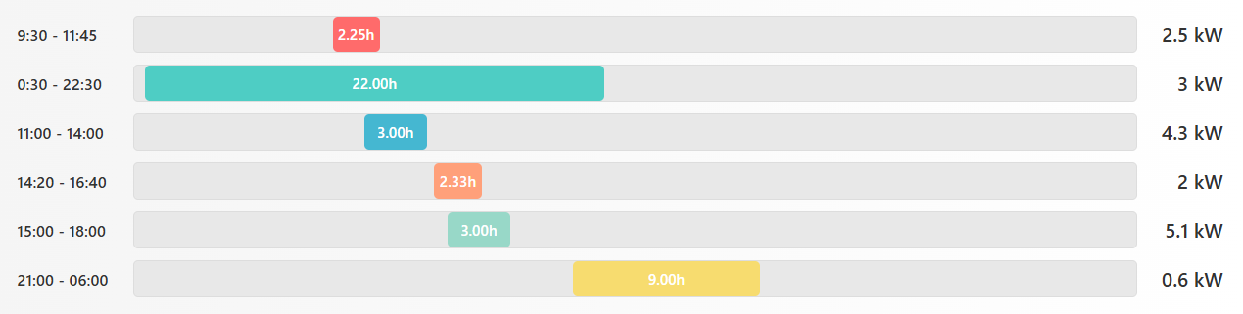

Energy Consumption Table
The table below is called "Energy Consumption Table". It holds all time intervals, based on the input data, along with their start time, end time, duration, power and energy consumption:
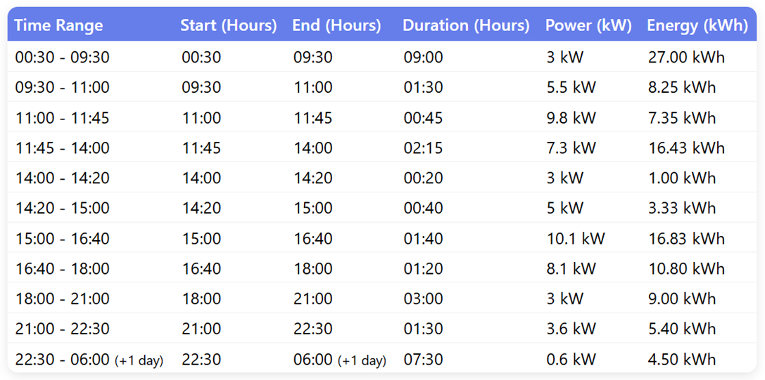
The table takes the start and end times from the input time slots, ordered chronologically.
- When two subsequent intervals have the same power, they should be merged (because they together represent one longer interval).
- Energy is calculated by power (in kW) * duration (in hours).
- Skip all empty intervals, where the power is 0.
It is visible from the table that the slot with the highest power is 15:00 - 16:40, with a peak power of 10.1 kW (3 kW + 2 kW + 5.1 kW):
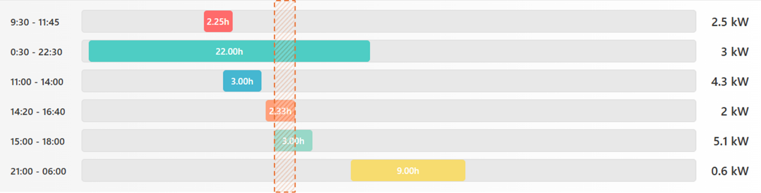

Input and Output
The input comes as array of strings, each holding start time, end time and power, in format "hh:mm - hh:mm -> X kW" (see the example below).
Return the output is a JS object, holding the following data:
- energyConsumptionTable : [ {startHour, endHour, duration, power, energy}, … ]
- peakPower : {startHour, endHour, duration, power, energy}
Use format "hh:mm" (with leading zeroes) for hours and durations, e.g. "03:00". Round the energy and power to 2 decimal places.

Sample Input and Output
Input | console.log(calcEnergy([  "15:00 - 18:00 -> 5.1 kW",  "0:30 - 22:30 -> 3 kW",  "11:00 - 14:00 -> 4.3 kW",  "21:00 - 06:00 -> 0.6 kW",  "14:20 - 16:40 -> 2 kW",  "9:30 - 11:45 -> 2.5 kW"  ]));
Output | {  energyConsumptionTable: [  { startHour: '00:30', endHour: '09:30', duration: '09:00', power: 3, energy: 27 },  { startHour: '09:30', endHour: '11:00', duration: '01:30', power: 5.5, energy: 8.25 },  { startHour: '11:00', endHour: '11:45', duration: '00:45', power: 9.8, energy: 7.35 },  { startHour: '11:45', endHour: '14:00', duration: '02:15', power: 7.3, energy: 16.43 },  { startHour: '14:00', endHour: '14:20', duration: '00:20', power: 3, energy: 1 },  { startHour: '14:20', endHour: '15:00', duration: '00:40', power: 5, energy: 3.33 },  { startHour: '15:00', endHour: '16:40', duration: '01:40', power: 10.1, energy: 16.83 },  { startHour: '16:40', endHour: '18:00', duration: '01:20', power: 8.1, energy: 10.8 },  { startHour: '18:00', endHour: '21:00', duration: '03:00', power: 3, energy: 9 },  { startHour: '21:00', endHour: '22:30', duration: '01:30', power: 3.6, energy: 5.4 },  { startHour: '22:30', endHour: '06:00', duration: '07:30', power: 0.6, energy: 4.5 }  ],  peakPower:  { startHour: '15:00', endHour: '16:40', duration: '01:40', power: 10.1, energy: 16.83 }  }

Energy Market
On the energy market, prices are changed every 15 minutes. Thus the 24-hour day is split into 96 intervals (24 hours x 4 intervals in each hour):
- Interval 1: 00:00 - 00:15
- Interval 2: 00:15 - 00:30
- ...
- Interval 96: 23:45 - 24:00
Energy pricing data typically comes as CSV file (pipe-separated) in the following text format:
Date | Interval | Price
2025-03-01 | 1 | 72.50
2025-03-01 | 2 | 71.90
... | ... | ...

TypeScript Classes
Define TypeScript classes / types to hold and process the energy pricing data:
- EnergyPriceEntry
  - Holds the energy price for certain 15-minute interval
  - Properties: date, interval (1…96), price
  - Calculated properties: startDateTime(), endDateTime()
  - Constructor
- MonthlyReportEntry
  - Holds data, used in the monthly report: month (1…12), min price, max price, average price
- EnergyPriceTable
  - Holds multiple price entries
  - Method addEntry(entry: EnergyPriceEntry) – appends an energy price entry
  - Method readFromCSV(string) – reads the prices from a string in CSV format (header + entries)
  - Method printAsCSV() -> string – returns the prices as CSV string (header + entries)
  - Method monthlyReport() -> MonthlyReportEntry[] – returns a pricing report, holding the min, max and average prices for each month in the year (see the example below)

Your Task
Implement the above-described TypeScript classes and write a TypeScript function to generate a pricing report by months from the input CSV data in the following text format:
# January
Min price: …
Max price: …
Avg price: …

# February
…

# December
…
- Skip the months without any data available.
- Round the prices to 2 decimal places.
- Disregard the year in calculations (only consider the month, mix the data from Jan 2024, Jan 2025, and other years).

Input Data
Input data comes as string holding the CSV pricing data in the above-described format. The first line is a header. All other lines hold an energy price entry. Each line ends with "\n".

Output Data
The output data is the report, returned by EnergyPriceTable.monthlyReport(), formatted as text.
- Return the output data as string.

Sample Input and Output
Input | Output
let pricesCSV =  `Date | Interval | Price  2025-01-05 | 1 | 65.30  2025-01-05 | 2 | 64.80  2025-01-15 | 10 | 68.90  2025-01-15 | 11 | 69.50  2025-01-20 | 20 | 71.80  2025-03-10 | 10 | 70.40  2025-03-10 | 11 | 69.80  2025-03-25 | 25 | 75.20  2025-03-03 | 3 | 76.50  2025-03-10 | 12 | 74.30  2025-03-15 | 20 | 73.10  2025-06-25 | 50 | 75.30  2025-06-25 | 52 | 64.20  2025-07-03 | 8 | 82.10  2025-07-12 | 18 | 81.40  2025-07-21 | 35 | 80.20  2025-08-01 | 4 | 79.80  2025-08-10 | 14 | 78.60  2025-10-16 | 24 | 69.50  2025-10-25 | 42 | 70.20  2025-12-28 | 55 | 74.20  2025-12-05 | 9 | 75.90  2025-12-06 | 90 | 15.80  2025-12-06 | 91 | 16.00  2025-12-15 | 25 | 76.40  2025-12-24 | 44 | 77.60`;  printMonthlyReport(pricesCSV); | # January  Min price: 64.80  Max price: 71.80  Avg price: 68.06  # March  Min price: 69.80  Max price: 76.50  Avg price: 73.22  # June  Min price: 64.20  Max price: 75.30  Avg price: 69.75  # July  Min price: 80.20  Max price: 82.10  Avg price: 81.23  # August  Min price: 78.60  Max price: 79.80  Avg price: 79.20  # October  Min price: 69.50  Max price: 70.20  Avg price: 69.85  # December  Min price: 15.80  Max price: 77.60  Avg price: 55.98

Judge Submission
Important: due to limitations in SoftUni Judge, you should put all your class definitions inside your function! You should submit to the judge just a single function, and all your type definitions, classes, and other code should be nested inside this function.

